**Science**

Ms. Derrah

623-445-8254

[Alice.Derrah@dvusd.org](mailto:Alice.Derrah@dvusd.org)

**Social Studies**

Ms. Schoettlin

623-445-8253

[Denise.Schoettlin@dvusd.org](mailto:Denise.Schoettlin@dvusd.org)

**5th Grade Website** - <http://5thgradepirates.weebly.com/>

**Language Arts**

Mrs. Walsh

623-445-8259

[Michelle.Walsh@dvusd.org](mailto:Michelle.Walsh@dvusd.org)

**Math**

Mrs. Rose

623-445-8260

[Robbie.Rose@dvusd.org](mailto:Robbie.Rose@dvusd.org)

**Norterra Canyon**

**5th Grade Handbook**

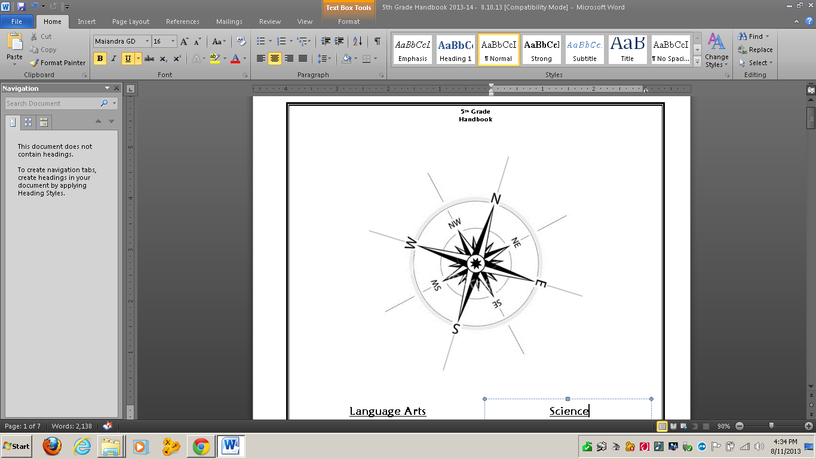

**Philosophy of Education**

We believe every child has the potential to learn and that each is an individual with unique learning styles. We will work diligently with our students to create a welcoming community in which all students can feel a strong sense of belonging. Students will also recognize that our classrooms are safe, orderly, and see that they have many opportunities to learn in an environment where time on task is valued, and high expectations are held. As teachers, we believe one of our key tasks is to learn all we can about our students and their unique learning styles. In doing this we are better able to deliver lessons that are student-centered, engaging and appropriate to their development. We will frequently monitor students’ progress and adjust our teaching to best meet their needs. Ultimately, we want our students to enjoy learning and look forward to coming to school every day!

**Daily Classroom Schedule**

MC900446326[1]8:15 – 9:30 …..….. Period 1

9:30 – 10:45 …..…. Period 2

10:45 – 11:30 ….… Special Areas

11:30 – 12:15 …..… Lunch / Recess

12:25 – 1:40 …..… Period 3

1:40 – 3:00 …..….. Period 4

**Special Areas**

Each student will have their own individualized special area schedule.

**5th Grade Curriculum**

Our curriculum is based on the Arizona Common Core Standards. You can access the standards at the Arizona Department of Education’s website (http://www.ade.state.az.us).

**Language Arts**

The Language Arts program consists of reading, writing, listening, and speaking.

These strands are interwoven and reinforced across the curriculum.

MCj04300490000[1]**Reading**

**Adopted Text:** Reading Street – publisher Pearson

**Curricular Focus:** Students will learn vocabulary, practice fluency and employ the appropriate reading strategies to comprehend and analyze a variety of literary genres and informational text.

By 5th grade, students are no longer just learning how to read, they are utilizing their reading skills in the other content areas, such as Science and Social Studies, in order to gain new information and apply it to their learning.

We will use a variety of teaching methods, including whole group, small-group, paired reading, and individual instruction to teach students the skills and strategies they need to be successful readers. Students will explore a variety of literary genres including mystery, science fiction, poetry, historical fiction, non-fiction, adventure, fantasy, fables, and myths.

Students can expect to have nightly homework in reading. Although the homework may not always be a pencil and paper task, it is expected that students read a minimum of 20 minutes per night.

**Writing**

**Adopted Text:** Write From the Beginning – publisher Jane Buckner

**Curricular Focus:** Students will effectively write a variety of quality writing pieces.

In order to meet the standards of the common core, writing will be occurring across the curriculum. Writing grades will come from all subject areas. In addition to their specialized area of instruction, each teacher will also have expectations in writing.

**Writing Forms**

* **Expressive writing** includes personal narratives, stories, poetry, etc.
* **Expository writing** includes nonfiction writing that describes, explains, informs, or summarizes ideas and content.
* **Functional writing** provides specific directions or information related to real-world tasks. This includes letters, memos, schedules, recipes, etc.
* **Persuasive writing** is used for the purpose of influencing the reader.
* **Literary response** is the writer’s reaction to a literary selection.
* **Research writing** is a process in which the writer identifies a topic to explore and/or question to be answered.

MCj02341340000[1]

**Writing Elements (Commonly referred to as 6-Traits)**

Qualities that define strong writing:

* Ideas (the meaning and development of the message)
* Organization (the internal structure of the piece)
* Voice (the way the writer brings the topic to life)
* Word choice (the specific vocabulary the writer uses to convey meaning)
* Sentence fluency (the way the words and phrases flow throughout the text)
* Conventions (the mechanical correctness of the piece)

**Writing Process**

The steps an effective writer uses to compose a writing piece:

Pre-writing - Drafting - Revising - Editing - Publishing

**Spelling**

**Curricular Focus:** Students will use a variety of strategies to spell words correctly.

Spelling will consist of units of 20 words of which 10 words will be tested weekly. In addition to the weekly spelling test, students’ daily writing will be assessed periodically.

**Math**

**Adopted Text:**  Investigations and enVision Math – publisher Pearson

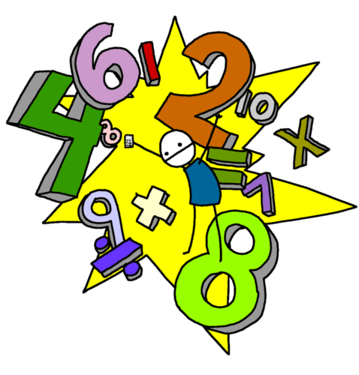***Common Core Standards for Mathematical Practice***

1. Make sense of problems and persevere in solving them

2. Reason abstractly and quantitatively

3. Construct viable arguments and critique the reasoning of others

4. Model with mathematics

5. Use appropriate tools strategically

6. Attend to precision

7. Look for and make use of structure

8. Look for and express regularity in repeated reasoning

**Curricular Focus:**

***Operations and Algebraic Thinking***

• Write and interpret numerical expressions

• Analyze patterns and relationships

***Number and Operations in Base Ten***

• Understand the place value system

• Perform operations with multi-digit whole numbers and with decimals to hundredths

***Number and Operations—Fractions***

• Use equivalent fractions as a strategy to add and subtract fractions

• Apply and extend previous understandings of multiplication and division to multiply and divide fractions

***Measurement and Data***

• Convert like measurement units within a given measurement system

• Represent and interpret data

• Geometric measurement: understand concepts of volume

***Geometry***

• Graph points on the coordinate plane to solve real-world and mathematical problems

• Classify two-dimensional figures into categories based on their properties

If your child is not proficient in their math facts (addition, subtraction, multiplication, and division), they should spend time mastering them on a daily basis. Math facts are a critical tool as the student progresses in their mathematical learning.

**Science**

**Adopted Text:** FOSS

**Curricular Focus:** Students will recognize the historical advancements of science and its importance on future generations as they explore key concepts in Life Science, Physical Science, and Earth & Space Science.

Science in the 5th grade allows students to explore topics through hands-on experiences. The program is intended to extend students’ natural curiosity about their world and to help them practice skills such as observing, questioning, testing, analyzing, and communicating thoughts and discoveries.

**MCj02320270000[1]**

* **Life Science** – functions of living systems
* **Physical Science** – properties of matter, motion and forces
* **Earth and Space Science** – Earth’s processes and systems, Solar System

**Social Studies**

**Adopted Text:** The United States: Making a New Nation – publisher Harcourt

**Curricular Focus**: Students will investigate the development of the United States from its earliest inhabitants to the end of the Civil War.

We will explore the following Social Studies topics using a variety of methods including class discussions, small groups, simulations, projects, research, and technology. Students will be expected to take notes in class and study/review them ­nightly (15 min.) for upcoming quizzes and tests.

* MCj01543740000[1]Economics (BizTown)
* Geography
* Exploration
* Colonization
* Road to Revolution
* Revolutionary War
* Constitution
* Government
* Western Expansion
* Civil War

**Homework /Late Work**

Homework is a nightly extension of our 5th grade curriculum. It provides students with an opportunity to reinforce their skills and hone their study habits. Homework is posted on the board in each class. Students are given time and required to write their assignments in their agendas. Your child may believe that he/she does not have homework because there is not a formal assignment to turn in. This is not always the case. Students are expected to study vocabulary, math facts, spelling words, geography, etc., nightly to master the Common Core Standards.

Students are expected to turn in all homework and class work on time. This teaches and reinforces responsibility and good habits that can last them a lifetime. Homework is due the next day unless otherwise specified. We understand that unique circumstances arise making it difficult to turn an assignment in on time. Therefore, students are given one late pass per subject, per quarter. After the pass has been used, late work turned in one day late will receive half credit. **This does not apply to long-term projects.**

**Make-up Work Due to Absences**

If a student is absent, he or she is required to make up any work missed, and will be given the same number of days as absent to make up the work. For example, if John misses 2 days of school, he would have 2 days after he returns to school to make up the work.

MCj04128080000[1]Assignments the student missed can be found on the board in the classrooms. Please keep in mind, many of our classroom activities cannot be completed at home (group work, experiments, in-class games, buddy class activities, etc), therefore, make-up work will be given upon students return to school. This includes extended absences due to illness or vacations.

**Birthdays**

Students may celebrate their birthday with their classmates. Treats must be store-bought, nut-free, simple, and easy to pass out. Birthday treats will be handed out at the end of the day.

**Parent -Teacher** [**C**](http://www.parenting-child-development.com/parent-teacher-communication.html)**ommunication**

We believe parent-teacher communication is essential to your child's [success in school](http://www.parenting-child-development.com/parent-teacher-communication.html). An issue cannot be resolved if the parent or teacher does not know about it. Below are a few ways we can communicate and create a strong parent-[teacher](http://www.parenting-child-development.com/parent-teacher-communication.html) relationship that will serve your child's best interests.

* **E-Blast** – This is a group email that will be sent out periodically with information that is relevant to 5th grade. Possible topics: upcoming events, projects, curriculum, etc.
* **Planner/Assignment notebook** - Students will receive an assignment notebook and are expected to record their homework in it each day. By doing so, students learn how to use a valuable organizational tool.
* **Papers Going Home** - Each week your child will bring home graded papers.
* **PowerSchool** – This is the online resource where parents can log on and view their child’s completed assignments and corresponding grades. To obtain your personal access code, please contact the front office at 623-445-8200.
* **Email**/**Voice mail** – The best and quickest way to make contact with the teacher is through email. We check our email and voicemail periodically throughout the day; however we may take up to 24 hours to respond to your message depending on our schedule. Please do not leave time sensitive messages. If you need to communicate something to your child during the school day, contact the office and they will get the message to the classroom. Our contact information. is in the front of the 5th Grade Handbook and the front cover of your child’s agenda.
* **Webpage** – If you are interested in finding information about curriculum, links to student resources, and classroom information, this is a great starting point.

5thgradepirates.weebly.com

MCBD10646_0000[1]

**Report Cards**

Report cards will be sent home quarterly.

**Grading Scale**

The grading scale, as required by the [Deer](http://www.pen.k12.va.us/Div/Stafford/grading.html) Valley USD:

|  |  |  |  |  |
| --- | --- | --- | --- | --- |
| A+ 98 - 100 | B+ 88 - 89 | C+ 78 - 79 | D+ 68 - 69 | F 59 and |
| A 93 - 97 | B 83 - 87 | C 73 - 77 | D 63 - 67 | below |
| A- 90 - 92 | B- 80 - 82 | C- 70 - 72 | D- 60 - 62 |  |

Grades will be determined by: daily work, quizzes, tests, projects and student effort.

**Weighted Grades**

Students will receive grades in two categories, homework/classwork and assessments. Grades will be weighted as follows:

90% - Assessments/Projects

10% - Homework/Classwork

**Discipline Plan**

The Fifth Grade Team strongly believes self-discipline and self-esteem are necessary for lifelong success. The plan we have developed provides every student with the opportunity to manage and accept responsibility for his or her own behavior. We believe all students can behave appropriately in the classroom and therefore adhere to the following discipline plan. (The philosophy behind “*Love and Logic*” is a driving force in guiding us to help our students become responsible, productive members of society.)

**Rules:** No one has the right to interfere with the learning, safety, or well-being of others.

The principles of Love and Logic are based on the following **TEACHER** guidelines:

* I will treat students with dignity and respect at all times.
* I will guide students to OWN and SOLVE their own problems.
* I will advise students to make decisions and then live with the consequences.
* I will use logical consequences instead of punishment when possible.
* I will treat the problem behavior as an opportunity for the students to grow.

The principles of Love and Logic are based on the following **STUDENT** guidelines:

* I will not cause a problem for myself or others.
* If the student does cause a problem for themselves or others, the teacher will act.

The following may occur if the student causes a problem for themselves or others:

* Time-out in classroom
* Time-out in Buddy Classroom and a Behavior Plan is completed (to be discussed with the teacher at a later time) and Parent Contact.
* Office Referral and Parent Contact

\*\* Depending on the severity of the behavior, the principal may implement one or more of the following for an office referral:

* Parent/guardian notification/conference
* Multiple detentions
* In-school suspension
* Off campus suspension
* Expulsion

\*\*\* Please note that steps may be skipped and consequences may vary depending on the severity of the infraction. District and school provided consequences will be utilized whenever necessary.

Write it on your heart

that every day is the best day in the year.

Ralph Waldo Emerson